Target Platforms
list the primary hardware you actively develop and test your game upon, incuding a summary of hardware specifications.
Save .txt (DxDiag) file in the Hardware Spec folder
Testing Hardware
Operating System: | Windows 11 Pro 64-bit
CPU: | AMD Ryzen 9 3900X 12-Core Processor ~3.8GHz
System Memory: | 64 GB RAM
GPU: | NVIDIA GeForce RTX 3070
Video Memory: | 8 GB VRAM
Storage: | 25 GB (required space on hard drive)

list YOUR RECOMMENDED target platform for the project, incuding a summary of hardware specifications. The recommended target is the minimal hardware to run your game with excellent performance. This may be the same as your testing hardware.
Save .txt (DxDiag) file in the Hardware Spec folder
Recommended Target Platform
Operating System: | Windows 10+ 64-bit or Mac OSX Sierra (10+)
CPU: | Core i5-7300U 3.5 GHz
System Memory: | 8 GB RAM
GPU: | NVIDIA GeForce GTX 660 or AMD Radeon HD 7870 or equivalent DX11 GPU
Video Memory: | 2 GB VRAM
Storage: | 25 GB (required space on hard drive)

list YOUR required target platform for the project, incuding a summary of hardware specifications. The required target is the minimal hardware to run your game with acceptable results. This may be the same as your testing hardware.
Save .txt (DxDiag) file in the Hardware Spec folder
Required Target Platform
Operating System: | Windows 7+ 64-bit or Mac OSX Sierra (9+)
CPU: | Core i3-3225 3.3 GHz
System Memory: | 4 GB RAM
GPU: | Intel HD 4000 on PC or Intel Iris Pro 5200 on Mac
Video Memory: | 1 GB VRAM
Storage: | 15 GB (required space on hard drive)

list any additional target platforms such as a mobile phone/tablet or console. choose a device that suits the average player you are seeking to market towards.
Save .txt (DxDiag) file in the Hardware Spec folder
Additional Target Platform (phone/tablet/console/etc.)
Operating System: | iOS 8 / Android 7
CPU: | Intel Atom Z2560 Dual Core 1.6 GHz or equivalent
System Memory: | 512 MB RAM
GPU: | PowerVR SGX544MP2 or equivalent
Storage: | 100 MB
Phone: | iPhone 4s / Samsung Galaxy S2 or equivalent

Load Times
Record the duration of your longest load times. Briefly describe the content being loaded, explain any prolonged durations, and offer solutions.

TIME: Explanations/remedY:
- 20s Level 1 load. Should asynchronously load shaders and mats during opening cut scene.
- 15s Level 2 load. Has more textures loaded but still hiccups
- 8s End of level. Occasional hiccup when finishing level
ADD ADDITIONAL TIMES AS NEEDED…

Benchmarks (utilize required platform if possible)
Save frametimes.csv and minmaxavg.csv files in the Benchmarks folder

Overall Performance:
Framerate: Duration: 58062 ms Min: 11 fps Max: 24 fps Avg: 22 fps
Memory (working set): 13.85 GB

Bottleneck – Level load:
Framerate: Duration: 4875 ms Min: 8 fps Max: 25 fps Avg: 17.85 fps
Memory (working set): 14.2 GB

Hotspot – Ability:
Framerate: Duration: 7297 ms Min: 17 fps Max: 23 fps Avg: 19.3 fps
Memory (working set): 13.8 GB

hotspot – trains:
Framerate: Duration: 5500 ms Min: 21 fps Max: 23 fps Avg: 22.36 fps
Memory (working set): 13.92 GB

Profiling data (Unity Sample)
Extract line items from the profiler and provide a screenshot or table documenting where CPU time is spent.
Save full .data file in the Profiler Reports folder

Overall Performance:
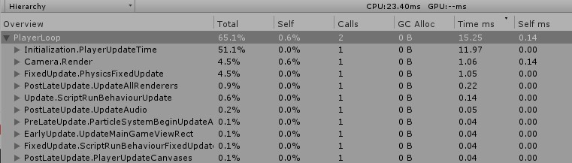

Profiling data (Unreal Sample)
Extract line items from the profiler and provide a screenshot or table documenting where CPU time is spent
Save full .ue4stats file (UE4) or .utrace file (UE5) in the Profiler Reports folder

Overall Performance:
Event Name | Inc Time (MS) | Inc Time (%) | Calls
FEngineLoop_UpdateTimeAndHandleMaxTickRate | 8.315 ms | 50.00% | 1
Total Slate Tick Time | 5.419 ms | 32.60% | 1
DrawStatsHUD | 1.116 ms | 6.70% | 1
FrameTime | 0.677 ms | 4.10% | 1
FEngineLoop_ProcessPlayerControllersSlateOperations | 0.501 ms | 3.00% | 1
Self | 0.272 ms | 1.60% | 1
Deferred Tick Time | 0.056 ms | 0.30% | 1
UI Drawing Time | 0.054 ms | 0.30% | 1
FEngineLoop_Tick_SlateInput | 0.035 ms | 0.20% | 1

Findings and remedies
plans to remedy the most pressing performance issues:

ISSUE: proposed remedy:
- Level Load Setup a speed-based occlusion predicter
- Abilities Remove mana calculations/checks on every tick
- Train Remove the physics body and raycast
ADD ADDITIONAL ISSUES AS NEEDED…

